Unit – II
EIA Methodologies
Criteria for the Selection of EIA Methodology:
EIA methodologies should have the following qualities
- Should be systematic in approach
- Should be able to organize the large mass of heterogeneous data.
- Should be able to quantify the impacts.
- Should be capable of summarizing the data.
- Should have a good prediction capability.
- Should extract the salient features.
- Should finally be able to display the raw data and derived information in a meaningful fashion.
Methodologies:
There is no universal methodology of EIA, so far which can be applied to all project types in all environmental settings. (Bisset, 1980)
- A number of methodologies are available for EIA.
- Warner (1973) has divided all available methods into 5 main categories.
(a) Adhoc Method
(b) Overlay Method
(c) Checklists Method
(d) Matrices Method
(e) Networks Method
- Apart from these, there are some specific approaches of economics like CBA, Input –output technique available for EIA.
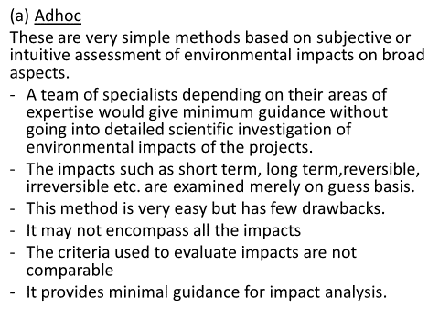
(b) Overlay Method:
-is a Geographical Approach developed by MC Harg (1968, 69).
-this method relies on maps of project areas, environmental characteristics covering Physical,
Social, Ecological and Aesthetic aspects.
- Comprehensive description of the areas is given.
- Computer programs are used to overlay the maps and thus arrive at a conclusion, reg. the impacts of the project.
(c) Checklist Method:
- Is different from adhoc methods.
- They are quite elaborate.
- Systematic assessment of environmental impacts of projects is done.
- Checklist means listing of Potential Environmental Impacts.
Types of Checklist: It is of 4 types
1) Simple Checklist- no information is given
2) Descriptive Checklist –gives data, measurement and impact prediction details
-by using the checklist method, EIA now assesses the nature of the impact i.e., adverse and beneficial, short term and long term, reversible and irreversible etc.
3) Scaling Checklist– is similar to descriptive checklist, and has additional information on subjective scaling of the parameters.
4) Scaling Weighing Checklist– is similar to scaling checklist with additional information on subjective evaluation of each parameter w.r.t all other parameters.
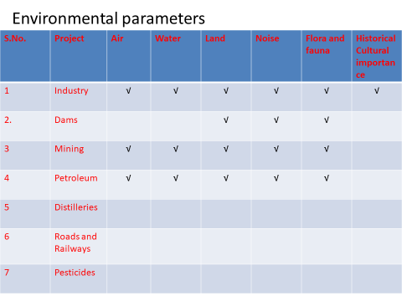
Types of Impacts of a Development Activity or Project on Environmental Components:
Short Term Impacts- loss of flora and fauna, soil erosion
Long Term Impacts- deforestation, desertification, increase in temperature, decrease in rainfall, climate changes
Direct Impacts–loss of flora and fauna, soil erosion, health hazards
Indirect Impacts- deforestation, desertification, increase in temperature, decrease in rainfall, climate changes, global warming, air pollution
Predictable Impacts: air pollution, water pollution, soil pollution, deforestation, loss of flora and fauna.
Unpredictable Impacts: global warming, depletion of ozone layer, acid rains etc.
Positive Impacts job opportunities, development of science and technology, increase in country’s economy, increase in goods, increase in consumerism, increase in standard of living.
Negative Impacts all the above except positive impacts.
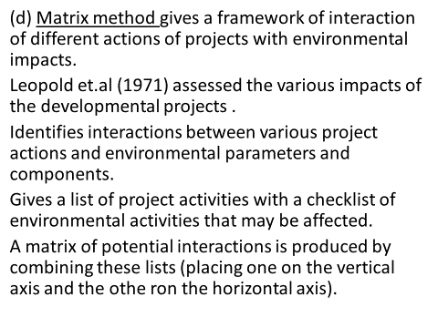
Cost Benefit Analysis (CBA)
- Also called Benefit Cost Analysis (BCA)
- Is a systematic approach to estimate the strengths and weaknesses of the options to achieve benefits while preserving savings (for eg. In transactions etc.)
- -CBA first compiles a comprehensive list of all the costs and benefits associated with the project.
- Costs include – cost of risks such as regulatory risk, (risk that a change in laws and regulations will impact a business or market etc.) environmental impacts etc.
CBA estimates and totals up the equivalent money value of the benefits and costs. These projects may be dams, highways, training programs, health care systems etc.
- Cost summary is broken down into its constituents and comparison of the costs is done.
There are 4 types of Cost Analysis
1) Investment Cost Analysis
2) Cost Allocation Analysis
3) Cost Effectiveness Analysis and
4) Cost Benefit Analysis.
CBA in EIA
CBA is undertaken to weigh the costs of a project against the benefits.
- CBA tries to put a monetary value on both costs and benefits so that they are expressed in same units.
- Environmental cost benefit analysis refers to assessing policies and projects that might affect the environment
- The Environmental Management Plan (EMP) covers the design, construction, operation and maintenance of each project component.
- EMP identifies the environmental issues and provides plans to manage them effectively.

Environmental Quality Index Method (EQIM)
- An overall estimate of environmental quality is needed to improve our understanding of the relationship between environmental conditions and human health.
- An Environmental Quality Index (EQI) was developed for all the countries using indicators from chemical, natural, built and social environment.
Five environmental domains are
- air
- water
- land
- Built and socio demographic.
EQI is used in 2 ways,
- As an indicator of ambient conditions in environmental health modelling,
- As a covariate to adjust for ambient conditions in environmental models.

Air Pollution Index
- Air pollution is a result of the combined effects of different pollutants rather than a single pollutant.
The magnitude of air pollution in such cases is difficult to be assessed on the basis of the concentration of individual pollutants alone, but the goal can be achieved by applying certain indices.
Water Quality Index
For calculating the water quality index,
There are 9 individual variables
- Dissolved Oxygen, Fecal Coliform
- pH, Biological Oxygen Demand
- Nitrates, Phosphates
- Temperature deviation, Turbidity and
- Total Solids
Other uses are expected by different end users such as
-Local People
-County
-State Govt.
-Non government organisations (NGO)
-Academic institutions
-EQI summarises many variables into a single variable.
-EQI is one approach that improves statistical efficiency and accounts for many environmental exposures at once.
-EQI identifies areas with different levels of environmental quality.
Deforestation:
refers to the elimination of forest resources or cutting of trees or loss of forest cover.
-in this process, the forest area is completely converted into agricultural area and then this area is converted into desert.
- The total forest cover of the world was 7000 M ha in 1900, which was reduced to 2890 M.ha in 1975, then fell down to just 2300 M.ha in 2000.
- Rate of deforestation is very less in temperate countries, but it is very high in tropical countries.
- In India about 1.3 M.ha. Is lost due to deforestation.
- The per capita availability of forest in India is 0.08 hectares per person which is much lower than the world average of 0.8 hectares.
Causes of Deforestation:
- Population Explosion
- Demand of Wood for Industries
- Mining Activities
- Overgrazing
- Construction of Roads and Railways
- Fires
- Developmental activities like Dams
- Agriculture
Population Explosion:
It is the main cause for all environmental problems including deforestation.
- As population increases, the requirement for timber, fuel, paper, wood increase.
- To meet these requirements, man has started cutting down the forests that caused deforestation leading to desertification.
- Felling of trees provides a source of income for billions of people throughout the world and forest products are useful in many ways.
Demand of Wood for Industries:
Wood is used for several industrial processes such as making of boxes, crates, packing cases, furniture, match boxes, paper, plywood etc.
Mining Activities:
Have a serious impact on forest resources.
-Large scale deforestation has been reported from Dehradun in 1989 due to indiscriminate cutting of forests for mining activities.
-Mining operations and dams’ damage and effect the valuable forest land.
-Dams also damage downstream eco systems.
Overgrazing
Of forests by livestock results in deforestation.
Construction of Roads and Railways
Along forests and mountains is also a cause of forest degradation.
Fire
Is the worst enemy of forest.it destroys the forest area and also causes large scale damage to animal life.
Developmental Activities
Dams, reservoirs, hydro electrical projects etc.
Projects submerge forest areas.
These forests displace large number of tribal people and cause great damage to forests.
Agriculture
Cutting of trees to cultivate agricultural land leading to deforestation.
Other Causes are
- Urbanization
- Subsistence Farming
- Desertification
- Mining
- Forest Mining
Types of Causes of Deforestation
1) Natural causes – flood, forest fire, climate change
2) Manmade causes – housing, agriculture, furniture
Effects of Deforestation or Environmental Impacts of Deforestation
1) Economic effects
2) Long term effects
3) Short term effects
- Effects – Short Lived Boom
- Long Term Effects
-Climate Change
- Global Warming
- Loss of Plant and Animal species
- Agriculture Damage
3) Short Term Effects
- Soil Erosion
-Change in Precipitation
Other Effects are
- Release of Green House Gases
- Droughts
- Increase in Temperature
- Animal Death or Extinction
- Vegetation and Resources lost-- Disrupted water cycles
- Disrupted Livelihood
- Loss of Biodiversity
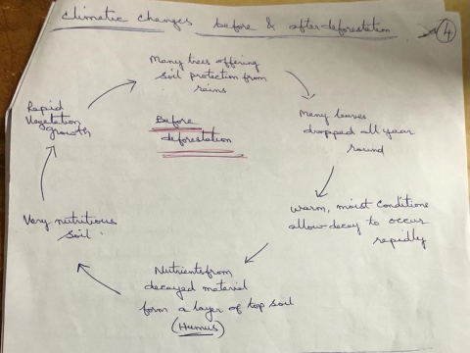

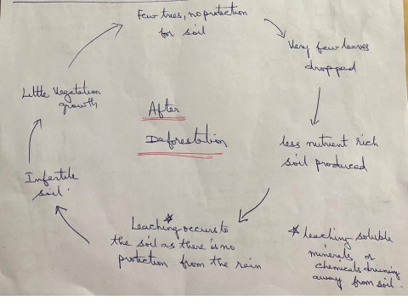
Impacts of Deforestation:
1)Impacts on Climate Change
-Drastic changes in climatic conditions
-Increase in temperature
- Changes in rainfall pattern
2) Impacts on Biodiversity
-loss of wild life species
-Extinction of flora and fauna
3) Impacts on Economy
Yield product decreases
4) Impacts on Land Resources
- Soil erosion
- Soil quality and quantity will be effected
- Loss of nutrients from soil
5) Impacts on Food Resources
-as yield production decreases, food production decreases.
- Lot of variation in supply and demand of product
- Increase in prices of food materials.
The main cause of Panda’s decline is deforestation. Since June 2019, there have been many bushfires burning across Australia (burnt area 18600000 hectares approximately, buildings destroyed 6500+)
Impacts on Vegetation and Wildlife
- The environmental analyst should assess the possible effects of developmental activity on vegetation and wild life.
- These impacts will be intense in rural areas for projects which cover large geographical Guidelines for preparing EIS Report
EIS Report contains 7 chapters
Chapter -1: Introduction
Chapter -2: The Site and Surroundings
Chapter -3: About the Project
Chapter -4: Environmental Effects of Project Operation
Chapter -5: Evaluation and Analysis of Impact
Chapter -6: Environmental Management Plan (EMP)
Chapter -7: Environmental Monitoring Programmes

Chapter -1: Introduction
This chapter would be introductory and background of the project. It gives details regarding the composition of the EIA study team, the budget adequacy (in professional person months), work plan, and the report organization should also form a part of this chapter.

Chapter -2: The Site and Surroundings
The chapter should include the following information.
• A description of the location and layout, including a vicinity map.
• Existing land use patterns should be described. Emphasis has to be on existing agriculture activities, presence of forest land, habitations, etc.
• Existing water use in the area is to be identified.
• Demographic profile which includes population density, population centres, and employment statistics.
• Soil profiles, including identification of soil types.
• Hydrology and water quality, which should include surface and groundwater resources, hydraulic, and water quality characteristics. Water quality parameters can be based on drinking water quality standards. Data on groundwater quality and the profile of the groundwater table, etc., should also be provided.
• Meteorology and air quality; meteorological data such as temperature, rainfall, relative humidity, wind speed and direction, and air quality data such as levels of nitrogen oxides, carbon monoxide, sulphur dioxide, hydrocarbons, etc.
• Ecology; ecological data will include a description of aquatic and terrestrial ecosystems in the area. Rare and endangered species, if any, will be identified.
• All the baseline information to be included in this chapter would be one year of monitoring data in the case of a detailed EIA.
Chapter -3: About the Project
This chapter should describe the relevant systems of the proposed project. This should include
- The Plant Layout,
- Drainage System,
- Description of materials utilized and produced (mass balance),
- Design criteria adopted and
- The access ways to be used.
Chapter -4: Environmental Effects of Project Operation
The anticipated impacts of the project operation on the environment should be described in this chapter.
- Impacts on air quality,
- water quality,
- agriculture and
- aquatic and terrestrial ecosystems have to be stressed.
EIA methods such as matrix and network, together with tools such as prediction models, may be useful at this stage.
All direct and indirect (first order and higher order) impacts should be speculated at this stage. To assist in this exercise, tools of prediction modelling may also be used, if necessary.
Chapter -5: Evaluation and Analysis of Impact
The type of evaluation method or tool, for example, weighted/scaled matrix, network, GIS, index method, cost-benefit analysis, etc., used to quantitatively evaluate the impact due to the proposed action, should be highlighted in this part of the report. Expert systems may also be useful for this evaluation.
Chapter -6: Environmental Management Plan (EMP)
This chapter should describe in detail the implementation plan to be adopted by the proponent during plant operation for the mitigation, protection, or enhancement measures which are recommended in Chapter 5. The EMP documents should contain an implementation plan for each of the selective mitigative protection and enhancement measures. The chapter may be structured as follows:
• Objective;
• Work plan;
• Implementation Schedule;
• Manpower Requirements;
• Budgetary Provision for EMP

This chapter is the most crucial and significant part of the entire EIA report.
Chapter -7: Environmental Monitoring Programmes
The proposed monitoring programmes to be implemented to monitor environmental impacts due to the operation of the project should be described in this chapter. The following sections have to be discussed:
• Surface Water;
• Groundwater;
• Air Quality;
• Ecological - Aquatic and Terrestrial;
• Socio-Economic Conditions.

